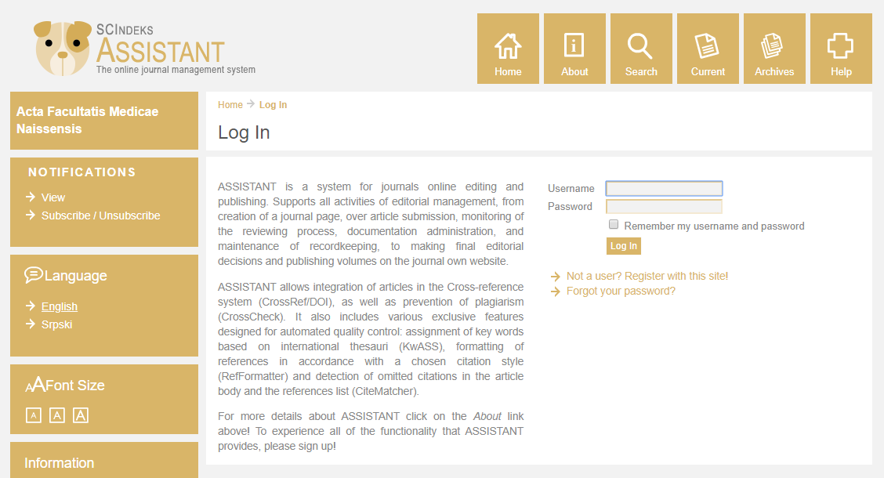
Updated: 03.01.2020.

Instructions for using the system Electronic journal editing
ASSISTANT
acta.facultatis@medfak.ni.ac.rs

Dear Sir/Madam,

From January 3, 2020, the journal Acta facultatis medicae Naissensis starts applying the on-line Electronic Editing (e-Ur) system (http://aseestant.ceon.rs/index.php/afmnai), developed by the Center for Evaluation in Education and Science (CEON). Therefore, the submissions (papers and peer reviews) are asked to be sent through the e-Ur system.

The service is intended to improve the editing efficiency as well as the quality and regularity of the peer review procedure; it also aims at preventing duplicate publishing and plagiarism, upgrading the article layout and, consequently, enhancing the quality and impact of the journal itself as well as that of the SCIndex base as a whole.

The application of the e-Ur service shows the readiness of the journal Acta facultatis medicae Naissensis, supported by IT technology, authors and the CEON, to endure in making constant advances in the influence, quality and internationalisation of papers, the journal and the base, including the progress in adherence to international ethical and publishing principles.

The electronic editing system will make the complete editing procedure faster, less complicated and more transparent, enabling the authors to follow their papers through all the phases of the editing procedure.

All authors, reviewers, members of the Editorial Board, co-workers and readers will find enclosed the Instructions for using the e-Ur system with the technical requirements to be met in future work as of January 3, 2020.

Having read the Instructions, you may start the process of registration.

Editorial office of the journal Acta facultatis medicae Naissensis

Instructions for using the system
Electronic Editing – ASSISTANT
of the journal Acta facultatis medicae Naissensis

- Creating the user account – User registration to the system
a) You can access the service through the site of the journal Acta facultatis medicae Naissensis , SCIndeks page, or ASSISTANT page, or directly at the ASSISTANT web address linked to the Acta facultatis medicae Naissensis. In the Jezik/Language menu choose the language of registration (English).
Click the Not a user? Register with this site option.
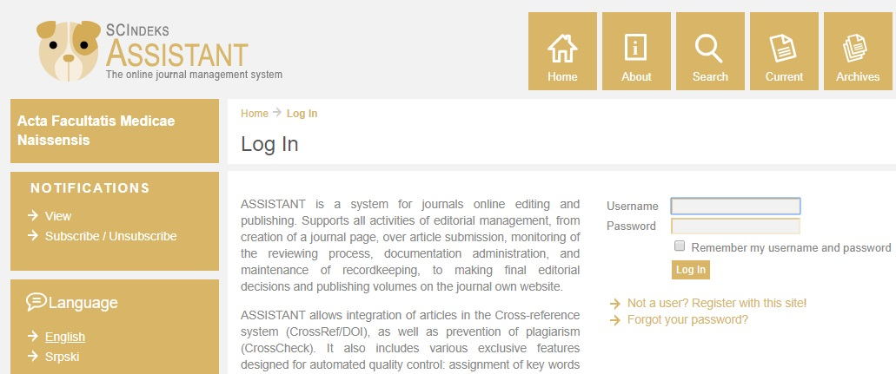
The Help option is on the right so you can access the detailed and precise instructions about the service at any moment.
b) On the registration page:
- All fields marked with an asterisk (*) are mandatory, and the registration process cannot be finished successfully without them. In case a mandatory field failed to be filled in, the system will remind you what to do in order to finish the registration.
- The remaining fields can also be filled in later using the My Profile option, after logging in the account. All user data can be ammended subsequently.
- Keep your user name and the password in a safe place in case you forget them.
- The page in English can be completed as follows:
  - In the Form Language menu choose the English option
  - Enter all data in English

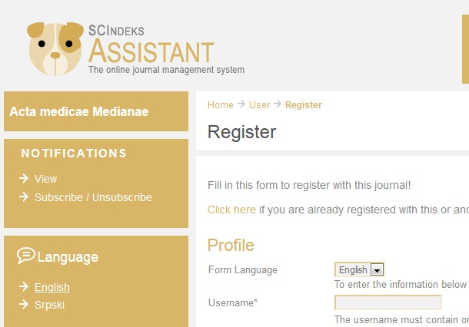

- The options concerning your status in the journal (author, reviewer)
  - reviewers and members of the Editorial Board should choose (click) the Reviewer option
  - Authors should be registered only as Author

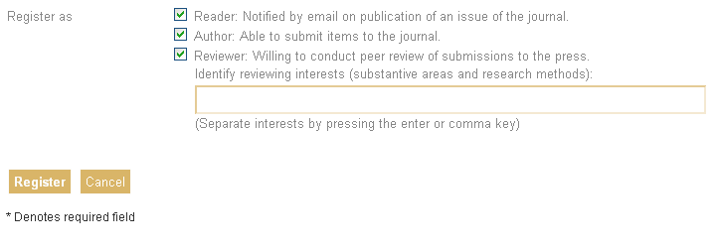

- The process is completed by clicking the Register button at the bottom of the page.
- The registration process is completed and you are automatically logged in your account.
For logging out see Instruction 2.c.

- Logging in for previously registred users – profile editing; logging out

- At the address of the ASSISTANT select the English language in the Jezik/Language menu, enter the user name and the password and click the blue Log in button.

- Your data can be ammended at any time through the My Profile option in the menu on the left. This option leads you to a page identical to that of the account registration. After entering changes, click Save to save the changes in your account.
- For logging out, click the Log Out option in the menu on the left.

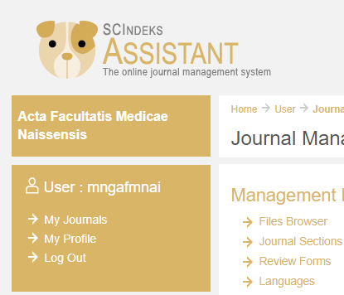

- Start a new submission – submitting the first version of the paper to the Editorial Office
After logging in (see Instruction 2.a), choose the Author option.
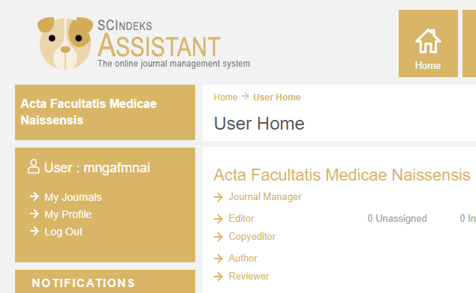

To start a new submission choose the Click here option.

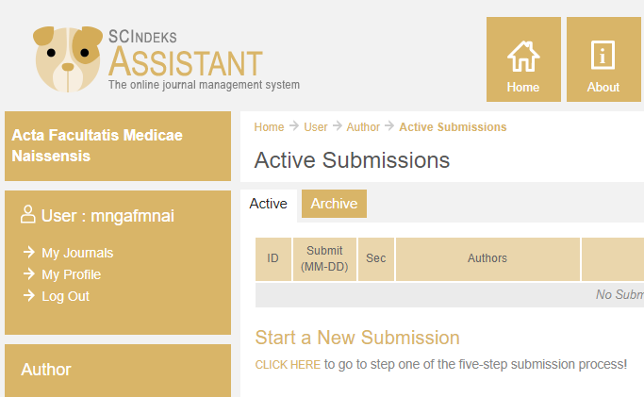

Step 1 in the submission process – Start
All fields marked with an asterisk (*) are mandatory, and the next step is not possible without them. In case a mandatory field failed to be filled in, the system will remind you what to do in order to procede to the next step.
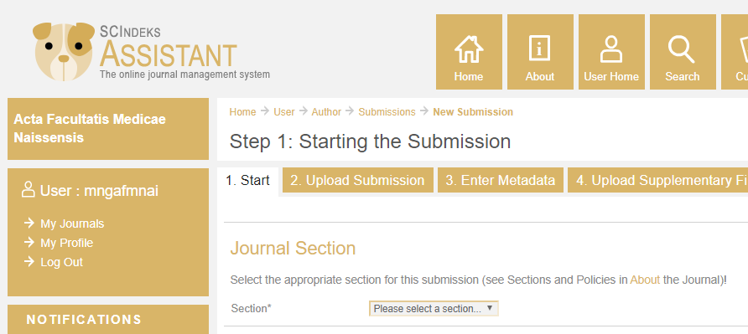
a) First choose the appropriate section (Section) for your submission since it is mandatory. If Editor-in-Chief finds your submission more appropriate for some other section, he will make a necessary change.

b) Your paper must meet all technical requirements, regardless of their current number or whether they have been changed since the last time you submitted a paper.
Read them carefully and confirm only if your submission complies with all of them.
If this is not the case, procede after editing it. Only when absolutely sure that
all the requirements are met, mark (check) all the fields.
Authors thus take the responsibility for their submissions meeting all the requirements, which will have an impact on the decision about taking them
into the editing procedure.
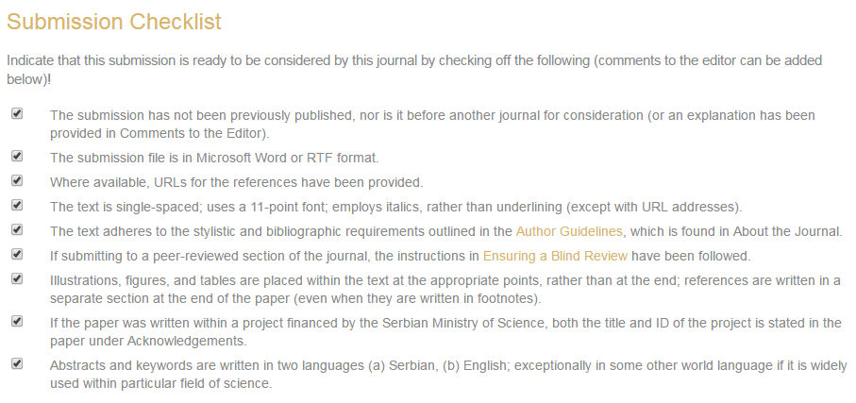
c) Procede to the next step by pressing the Save and continue button at the bottom.
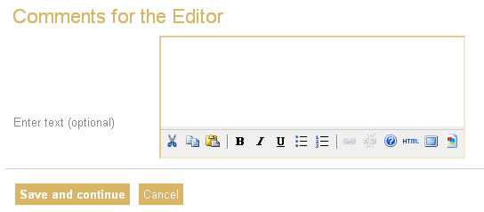
Step 2 in the submission process – Upload Submission

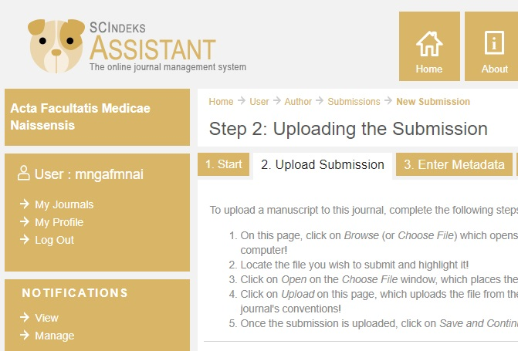
- In this phase Authors submit the file in the WORD format.
- Authors should be aware that submitted papers represent versions to be peer reviewed. Papers already been reviewed out of the system should not be submitted. The purpose of the ASSISTANT system is editing as well as reviewing through the system, which helps evaluating the journal editing quality and the quality of the paper itself.

Follow the detailed file submitting instructions given on the current page:
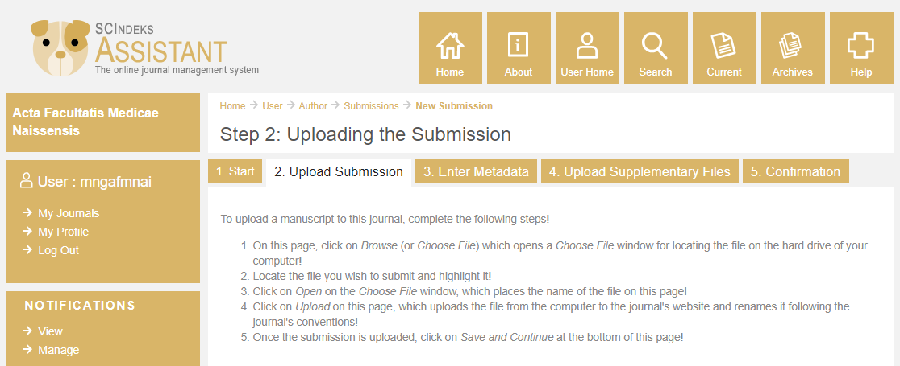

Step 3 in the submission process – Enter Metadata

This is the most important step in the submission process.

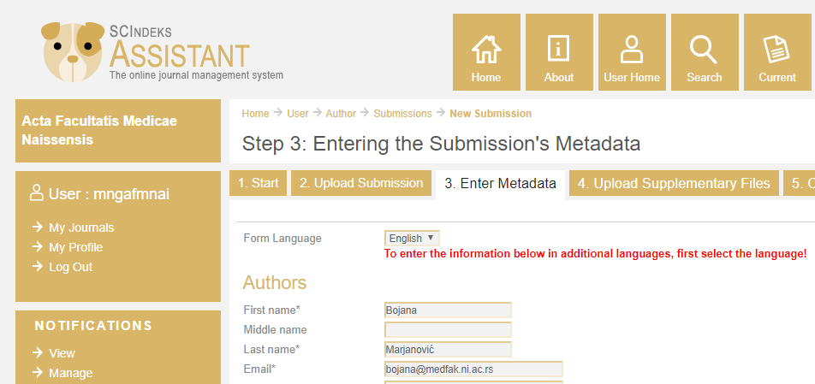

Metadata is the data about the paper not only incorporated in the paper iteself but also separately entered into the system for following the paper in the publishing process as well as for the further monitoring of paper citations and other relevant parameters.
Metadata includes:
- data on the author (s)
- title and abstract
- other data
Key words are system-generated on the basis of the title and the abstract in English. Having the paper approved by the reviewers, the author is asked to check, select and possibly add the key words for the Metadata Editing Section.
- Data on the author(s) is automatically generated from your profile.
- All fields marked with an asterisk (*) are mandatory, and the next step is not possible without them. In case a mandatory field failed to be filled in, the system will remind you what to do in order to procede to the next step. Filling in the remaining fields is encouraged.
The page MUST BE COMPLETED in English as follows:
  - Choose the English option in the first Form Language menu
  - Enter all metadata in English

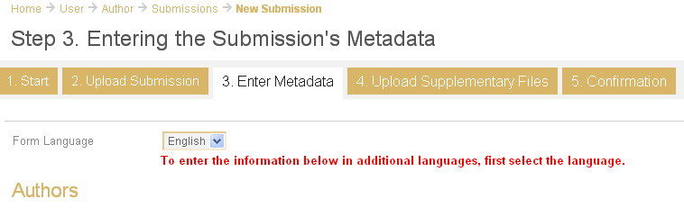
Procede to the next step by clicking the Save and continue button at the bottom.
Step 4 in the submission process – Upload Supplementary Files
- This step is NOT OBLIGATORY. It enables submitting supplementary files if appropriate.
- The Article Formatting Instructions of the Acta medica Medianae state that all figures, graphs, illustrations, etc. are to be incorporated into the body of the paper in the prescribed Article Form.

Step 5 of the submission process – Confirmation
- In the last step, clicking the file name in the Original file name field enables you to check, last time before uploading, whether you incorporated all required documents into the system.
- The submission process is finished by clicking Submit and your paper is downloaded in the Editorial Office.

- Editing stage
- After being submitted, the paper enters the editing process. Authors are kindly asked to check regularly the email address given at the registration since the system-generated information about the current editing phase is sent to it.
- The email address to which information is automatically sent can be changed using the My profile option (see Instruction 2.b).
- Besides being informed by electronic mail, Authors can follow the editing process by accessing the system (see Instructions 2) at any time.
- Having submitted the paper (see Instruction 3.a), choose the Author option.
- You have entered the Active Submissions window where you can see the status of all your submissions.
- Clikcking the active options enables you to be informed about:

- the submission itself, by clicking the active submission title
- the editing process and the timetables for particular editing phases, by clicking the active submission status

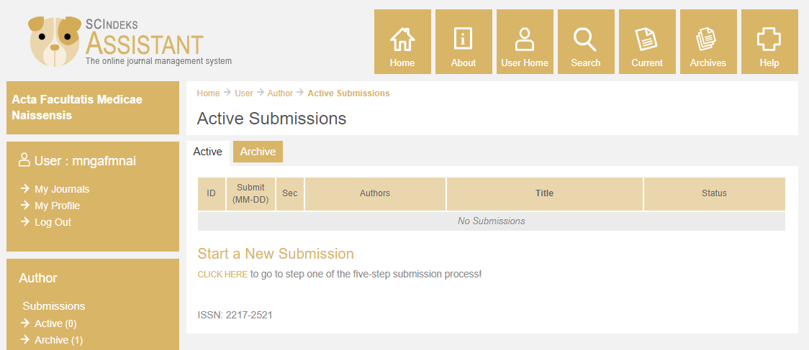
1
2

- Editor’s Help
- Editor’s help is offered in order to facilitate the switch to the new system of editing the journal Acta facultatis medicae Naissensis and to make contacts with the Editorial Office faster and more efficient. For any kind of help, Authors should feel free to contact Editor acta.facultatis@medfak.ni.ac.rs.
- AT ANY TIME AUTHORS CAN ACCESS THE DETAILED AND PRECISE INSTRUCTIONS ABOUT THE SERVICE THROUGH THE HELP PAGE (FIRST ON THE RIGHT IN THE TOP MENU)

Editorial office of the journal Acta facultatis medicae Naissensis

